OVERVIEW:
This document has been prepared to promote a safe return for children and staff to Immanuel Preschool of Shillington. This plan will define policies and procedures related to the COVID 19 Pandemic that are necessary to provide for the safest preschool environment possible.
These policies will remain in effect indefinitely and are subject to change as the guidance from the CDC, and local and state authorities change. Any changes to these policies and procedures will be immediately communicated to preschool families and preschool staff, and any additional necessary training will be completed promptly by all preschool staff.
These policies and procedures have been thoughtfully considered with the highest priority given to maintaining the health and safety of our students and staff. We recognize that additional decisions regarding how to apply this policy and how to handle situations that are outside of what has been documented within this policy will likely arise, and we intend to follow the spirit of this document and uphold the health and safety of students and staff in all decisions. We also acknowledge that not every situation is the same, and we are committed to reviewing all situations on a case by case basis in order to make the best decision possible based on the specific facts and information at hand.

STAFF BUILDING PROCEDURES:
TRAINING: All preschool staff will receive a copy of this plan and will also attend a training session which will detail how to implement each procedure. Staff will understand their role, which is to model health and safety practices so children can become successful at learning these new practices. This training will be completed during the August In-Service prior to opening the preschool to students and will be repeated as needed for any additional staff or changes to policies and procedures.
In addition, our preschool and church staff were trained on COVID-19 including disinfection and cleaning practices through a live presentation from Elk Environmental Services/Empire Group or a recorded webinar of the presentation.
CLEANING & DISINFECTING: Cleaning and disinfecting of spaces and equipment will be the responsibility of all staff members.
- Frequently touched surfaces will be disinfected throughout the school day by preschool staff.
- Tables and common surfaces will be disinfected during class transitions, before snack, after snack and at the close of class. Tables will be cleaned and disinfected before and after each activity (fine motor activities, art and snack) by classroom staff.
- Toys used will be disinfected after use by preschool staff.
- Playdough and pencil cases (containing crayons, glue stick, scissors) will be put together for individual use with no sharing.
- Soft toys (stuffed animals) and cloth toys (dress-ups) will not be used at this time.
- Sensory bins and tables may be utilized with student hand washing before and after use.
- Staff will vacuum and clean and disinfect toys/learning materials daily, after class.
A system has been implemented for communicating with the in-house custodial staff regarding specific areas requiring attention. The cleaning team will do the following daily, after staff and children leave the building:
- Empty trash, replace disposable bag and clean and disinfect the outside of the can.
- Clean and disinfect all frequently touched surfaces.
- Clean and disinfect bathrooms.
- Vacuum and wipe down halls and stairwells.
- Address any other specific areas requiring attention.
Ongoing cleaning and disinfecting will be documented as deemed necessary by the Preschool Director and Church Leadership.
The in-house custodial team has verified that the cleaning and disinfecting supplies are registered by the EPA as effective against SARS-CoV-2, the virus that causes COVID-19. Cleaning and disinfecting will be done in accordance with the guidance set forth by the CDC regarding methods and frequency of cleaning and disinfecting.
The building has been thoroughly disinfected and largely vacant throughout the summer and is currently fully cleaned and disinfected in preparation for the upcoming school year. Thorough cleaning and disinfecting protocols will continue throughout the school year.
CLEANING & SAFETY SUPPLIES/MATERIALS: The following list of supplies will be needed prior to the start of the preschool year in order to comply with the guidelines set forth by PA Department of Health and CDC.
- No touch trash cans
- Cloth Face Coverings (as feasible)
- Disposable PPE (such as masks and gloves)
- Soap and Hand Sanitizers (with at least 60 percent alcohol)
- Paper Products (such as paper towels, tissues, etc.)
- Cleaning Supplies (including disinfectant wipes)
BUILDING VENTILATION: The heating, ventilation, air conditioning and water systems are routinely inspected and remedial action taken as part of our normal building maintenance throughout the year. Building maintenance during the COVID 19 Pandemic has continued and the building systems are working properly and are ready for building occupation and increased building use.
DROP-OFF AND PICK-UP PROCEDURES:
STUDENT DROP-OFF: Students will be greeted upon arrival at the designated entrance by a preschool staff member who will assist the student out of their vehicle and into the school building. Additional drop-off information, including timing for each class and maps for forming lines and student entrance to the building will be distributed.
Family members should refrain from entering the school building. Family members can make an appointment with the Preschool Director if access to the building is needed for any reason.
A staggered start-time will be utilized to minimize the interaction of children in different classes.
The individual present at drop-off will be asked to verify that their student is in compliance with the Daily Health Check Questions as detailed in this document. In preparation for these questions, parents are asked to take their child’s temperature daily before leaving home; students may not attend preschool with a temperature of 100.4 or higher. Any staff member or student with symptoms of illness will not be admitted in the building.
Before assisting students out of the car, a preschool staff member will take the temperature of each student, verifying that the temperature does not exceed 100.4 degrees or higher. Any student with a temperature of 100.4 or higher will not be removed from the car. In order to perform the temperature check safely, the student will be required to have his or her mask on; please have students ready with their mask on as they approach the door for drop-off.
All families will be required to sign a document confirming that you will answer the Daily Health Check questions to the best of your knowledge daily. These daily responses will be documented and retained by preschool staff and will be referenced as needed in accordance with the guidance set forth by the PA Department of Health.
In addition, the preschool reserves the right to take student and staff temperatures at any time throughout the day with an infrared no touch thermometer; temperatures may be taken at random or as deemed necessary.
VISITORS & BUILDING ACCESS: To the greatest extent possible, adult visitors and volunteers will not be permitted in the preschool and ask that family members refrain from entering the building without an appointment. We are temporarily placing a hold on any BCIU staff, photographers, or community visitors.
Large group gatherings with families present will be temporarily discontinued. When possible, other methods for celebrating together will be utilized, such as Facebook Live and/or Zoom.
STUDENT PICK-UP: Students will be escorted to the car line-up at the designated exit by a preschool staff member who will assist the student to their vehicle. Additional pick-up information, including timing for each class and maps for forming lines and student entrance to the building will be distributed.
Family members should refrain from entering the school building. Family members can make an appointment with the Preschool Director if access to the building is needed for any reason.
A staggered end-time will be utilized to minimize the interaction of children in different classes.

CLASSTIME POLICIES & PROCEDURES:
EMOTIONAL SUPPORT: We will do all we can to help children adjust to preschool. We want them to feel safe, happy and comfortable. Teachers will be prepared with stories and audio/visual programs to assist children with any worries or concerns regarding all the changes being implemented. Social stories and discussions will be utilized on hand washing, germs, coughing and sneezing into elbows, refraining from touching your face and others, and caring for everyone’s health as well as our own. Staff will model how to be healthy and safe while at preschool. We will do our very best to provide a developmentally appropriate environment, where children can play, learn, explore and enjoy childhood!
CLEANING HANDS: Students and staff will wash their hands for at least 20 seconds with soap and water upon entering the school/classroom after car drop off, after restroom use, before and after snack, after active play & sensory play, after sneezing or using tissues and any other time their hands get dirty due to painting, coloring, etc.
Hand sanitizer will be available at all times to supplement times when a sink is not available.
FACIAL COVERINGS: We are complying with the order set forth by the PA Department of Health, that requires all adults and children over 2 years old to wear a face when leaving their homes. Face coverings must be worn when arriving and departing from preschool.
Children should come with a mask already on their face. Children should have their own mask that fits their face well and is as comfortable as possible for them. The classroom teachers will have “mask” bins with student names for students to take off and store their mask. The Dept. of Health recognizes that getting younger children to be comfortable wearing face coverings and to keep them on may create some difficulties and has issued guidance stating that in the school setting we may consider prioritizing the wearing of face coverings to times when it is difficult to maintain social distance. Ensuring proper face covering size and fit may help address the issue. Students may remove masks during the following activities:
- Outdoor play
- Snack time
- Sitting at classroom tables at least 6 feet from others
- Any other activity that provides for a six-foot distance from others. We will do our best to provide activities where social distancing is attainable in order to limit mask-wearing.
Exceptions to the facial covering guidance were listed in the July 8, 2020 revision of the PA Office of Child Development and Early Learning: If a parent, guardian, or responsible person has been unable to place a face covering safely on the child’s face, they should not do so. If a child 2 years or older is unable to remove the face covering without assistance, the child is not required to wear one.
Staff will wear masks or face shields throughout the entire school day.
CLASSROOM SET UP: Students will be spaced 3-4 to a table for table play and tables will be spread out throughout the classroom. Circle time spots on the carpet will be spaced at a greater distance than in the past either by sticker dots or sit-upons that will be disinfected after circle time. If a classroom cannot distance the students 3-6 feet apart for circle gathering, a split circle time may be utilized (1/2 class at a time).
SHARED SPACES: Communal spaces such as hallways, restrooms and the playground will be utilized by the classes using a time schedule and common surfaces will be sprayed/wiped with disinfectant between class use.
CLASSROOM SEPARATION & SOCIAL DISTANCING: Teachers and students will remain in the same classroom for the class day with the exception of restroom time & active play. Spacing will be marked by dots for lining up to walk in the hall, sitting in the hall at restroom time and dismissal. Students will not interact with other classes.
Stay and Play Class will not permit drop-in students at this time to keep the class constant and smaller in size. Students will not be able to switch days for stay and play and can only attend the days they have signed up for prior to school’s opening.
ITEMS FROM HOME: Except for a change of clothing and any necessary outerwear, please keep all other items at home. We will temporarily discontinue Show and Tell to avoid items going back and forth between home and school. Backpacks will not be used until further notice. If your child is enrolled in our Stay and Play Class, place their lunch in a disposable bag with their name clearly marked.
FIELD TRIPS & SUPPLEMENTAL PROGRAMS: Field trips will be temporarily discontinued. Supplemental programs such as Kindermusik and Soccer will be discontinued for the Fall and will be reconsidered for the Spring.
OUTDOOR AND INDOOR PLAY: Children will continue to play outdoors whenever possible. Class times will be staggered so there is no overlapping of classes on the playground or in the halls. Children will wash hands before returning to their classrooms. Cleaning and disinfecting will occur in between classes. The same procedure will take place when using indoor shared spaces when inclement weather prevents outdoor play.

ILLNESS POLICY:
DAILY SCREENING & ATTENDENCE RECORDS: All students and staff must be in compliance with the Daily Health Screening Check each day before entering the school building. A record will be kept verifying each individual’s compliance daily. We will be keeping an accurate attendance record for staff, students, and anyone else who enters the school. This information will be needed if contact tracing becomes necessary.
If a staff member or student is not in compliance with the Daily Health Screening Check, they must stay home and may not enter the school building. Students and staff who fail the Daily Health Screening Check cannot return to the school until they have satisfied the qualifications for Discontinuing At Home Isolation as outlined below.
BECOMING SICK AFTER ARRIVAL: If a student becomes sick at school or shows any symptom of illness, the child will be removed from the classroom and placed with a staff member to be cared for in a separate, isolated room until an authorized pick-up person arrives. The student will be taken out to the authorized pick-up person’s car.
If a staff member feels ill at school they will be sent home immediately.
Students and staff who are sent home due to illness cannot return to the school until they have satisfied the qualifications for Discontinuing At Home Isolation as outlined below.
DISCONTINUING AT HOME ISOLATION:
- If a student or staff member receives a confirmed COVID-19 diagnosis, the preschool will contact the local health department and follow all subsequent recommendations.
- All students and staff in the same classroom or who have come in close contact (defined as greater than 10 minutes of interaction less than 6 feet away) with a symptomatic individual should quarantine at home for 14 days. Anyone who develops symptoms during that time should contact their health care provider, and follow guidance for monitoring illness and staying home.
- Staff members who test positive for COVID-19 or who are awaiting testing may not return to the school until a medical release is received and they are asymptomatic for more than 3 days following a minimum of 14 days absence.
- Individuals with suspected or confirmed cases of COVID-19 do not need a doctors note to return to school, but must follow the guidelines for monitoring and staying home as follows:
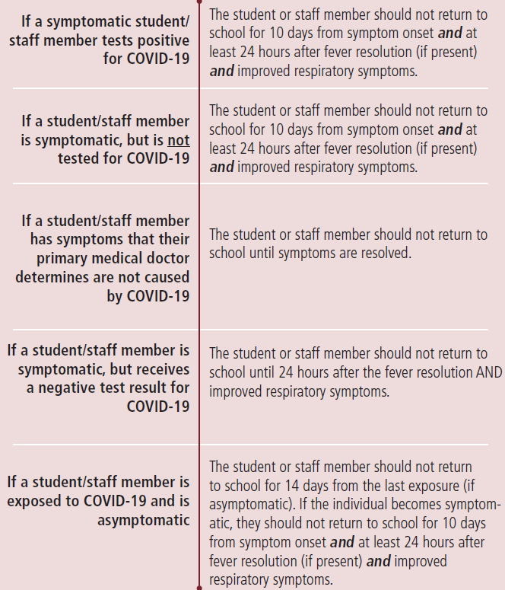
NOTIFICATION OF CONFIRMED CASES: If a student or staff member is diagnosed with Covid-19 our school will notify families, school, church, and local health authorities (PA Department of Health) and follow their guidance as to facility closing for cleaning and disinfecting. A record of absenteeism will be maintained.
TUITION REFUNDS: Due to the current environment and presence of COVID 19 in our area, we believe it is prudent to expect that there may be some interruption to individual student attendance, specific classroom attendance, or full school attendance at some point in the school year.
- Students who may be exposed to COVID 19 due to a household member’s exposure or diagnosis of COVID 19 will be absent during quarantine.
- Local, state, or federal authorities could mandate the temporary closure of the school due to the COVID 19 virus and spread.
- Classrooms who experience confirmed exposure to COVID 19 will be absent during quarantine.
In order to provide a continuous, quality educational experience for the school as whole, we do not anticipate refunding tuition to families based on these absences. For extended absences (in excess of 2 weeks) related to COVID 19, tuition deferments will be considered on a case by case basis. In all cases, every effort will be made to provide supplemental materials for use at home with preschoolers during their absence.
If the local, state, or federal authorities mandate that schools close for more than 2 weeks, tuition will be suspended until in-person instruction resumes. In that scenario, a partial tuition option may be made available for continuing some activities at home through Zoom meet-ups, lesson videos & craft/ task learning packets for use at home.

DAILY HEALTH SCREENING CHECK:
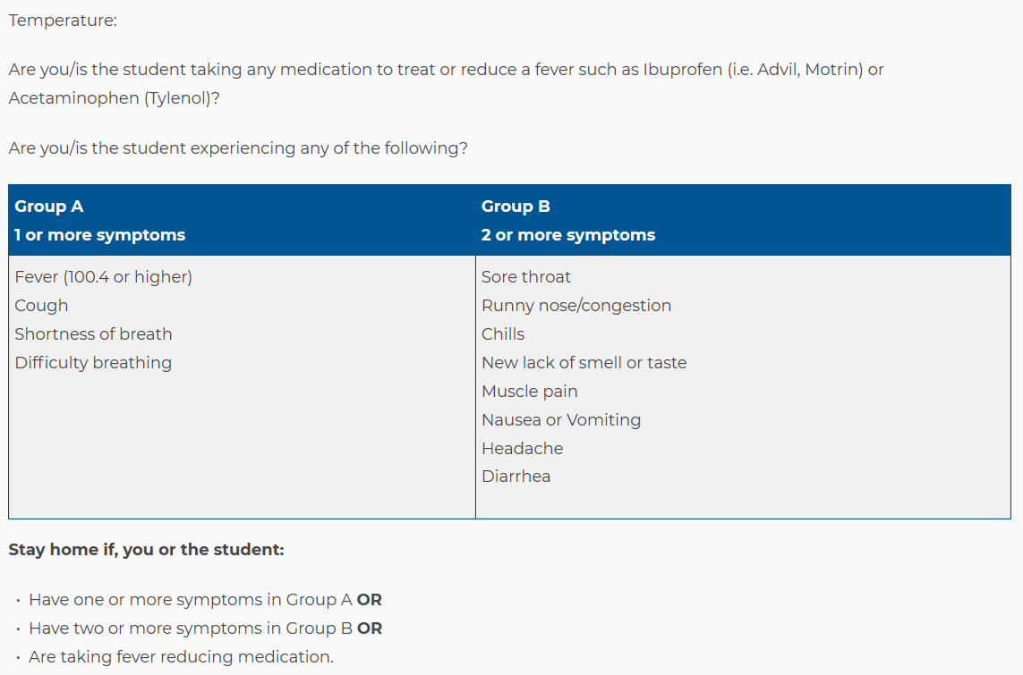
Obtained from PA Department of Health Guidance for School Reopening:
https://www.education.pa.gov/Schools/safeschools/emergencyplanning/COVID-19/SchoolReopeningGuidance/ReopeningPreKto12/PublicHealthGuidance/Pages/default.aspx

Additional Questions:
In the last two weeks has your child or anyone in your household:
- Been diagnosed with Covid-19
- Traveled to a high-case location listed on the PA.GOV website: https://www.health.pa.gov/topics/disease/coronavirus/Pages/Travelers.aspx
Is anyone in your household currently under voluntary or involuntary quarantine or have been within the last two weeks?

